6-Person Core Team (MavunoSasa)

Name: KELVIN JOSEPH-
Tittle: Chief Executive Officer (CEO) & Co-Founder
Role focus: Vision, partnerships, fundraising, strategy
Why this title works:
- Expected by donors, incubators, and investors
- Owns external relationships (government, donors, AfriAI, partners)
Typical responsibilities:
- Sets vision and long-term strategy
- Leads partnerships and fundraising
- Represents MavunoSasa publicly
- Oversees impact and growth strategy

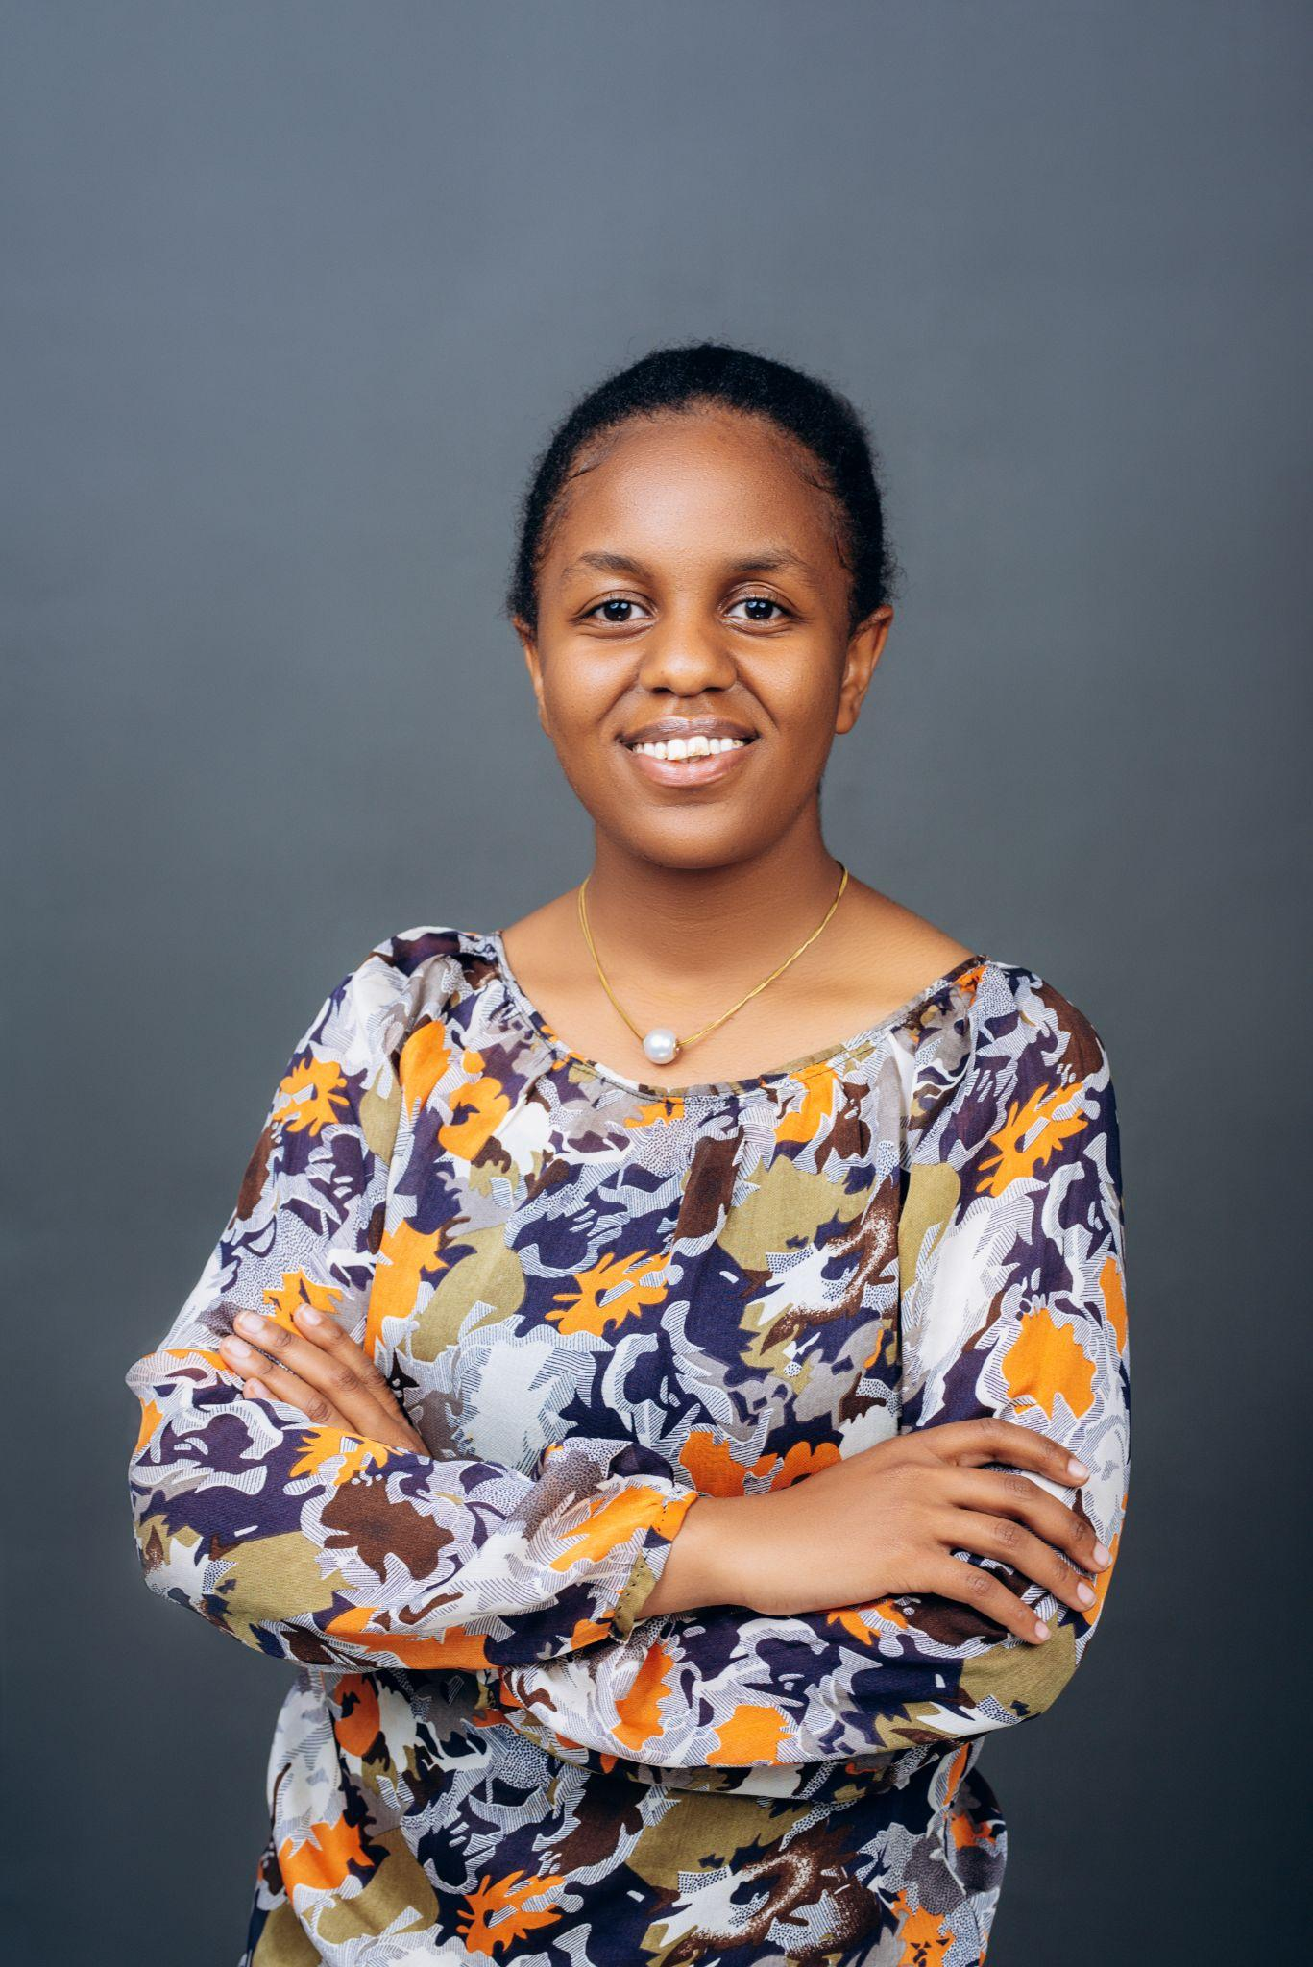

Name: Regina Mlay
Tittle: Chief Technology Officer (CTO) & Co-Founder
Role focus: Platform architecture, scalability, security
Why this title works:
- Signals technical depth and long-term product ownership
Typical responsibilities:
- Leads backend, integrations (USSD, SMS, WhatsApp)
- Oversees system architecture and data security
- Guides the engineering roadmap and scalability



Name: Emanuel Silayo
Tittle: Head of Data & AI (Lead Machine Learning Engineer)
Role focus: AI/ML models, analytics, predictions
Why this title works:
- Directly aligns with the AI Innovator’s Challenge
- Shows responsible AI ownership
Typical responsibilities:
- Builds risk-scoring and prediction models
- Designs data pipelines and monitoring
- Ensures AI is playbook-bounded and explainable
- Measures model performance and impact



Name: Simon Flavian

Tittle: Head of Product & User Experience
Role focus: Product design, farmer usability, workflows
Why this title works:
- Shows farmer-centered design and execution discipline
Typical responsibilities:
- Defines product requirements and roadmaps
- Designs farmer, agent, and dashboard experiences
- Ensures USSD/SMS flows are simple and usable
- Coordinates feedback loops with field teams


Name: Angel Msechu

Tittle: Head of Field Operations & Partnerships
Role focus: Deployment, farmer onboarding, local partners
Why this title works:
- Extremely important for Tanzania context
- Signals you are not “tech-only.”
Typical responsibilities:
- Manages agent network and onboarding
- Coordinates extension officers and farmer groups
- Oversees training and pilot roll-outs
- Ensures data quality from the field


Name: Christina Mlay
Tittle: Agronomy & Extension Lead
Role focus: Crop expertise, playbooks, advisory quality
Why this title works:
- Builds trust with farmers, government, and donors
- Balances AI with real agronomic knowledge
Typical responsibilities:
- Develops and validates crop-stage playbooks
- Works with extension officers and researchers
- Ensures recommendations are locally relevant
- Supports evaluation of farming outcomes

